Lab 05 - Implement Intersite Connectivity

Student lab manual

Task 1: Setting up the environment

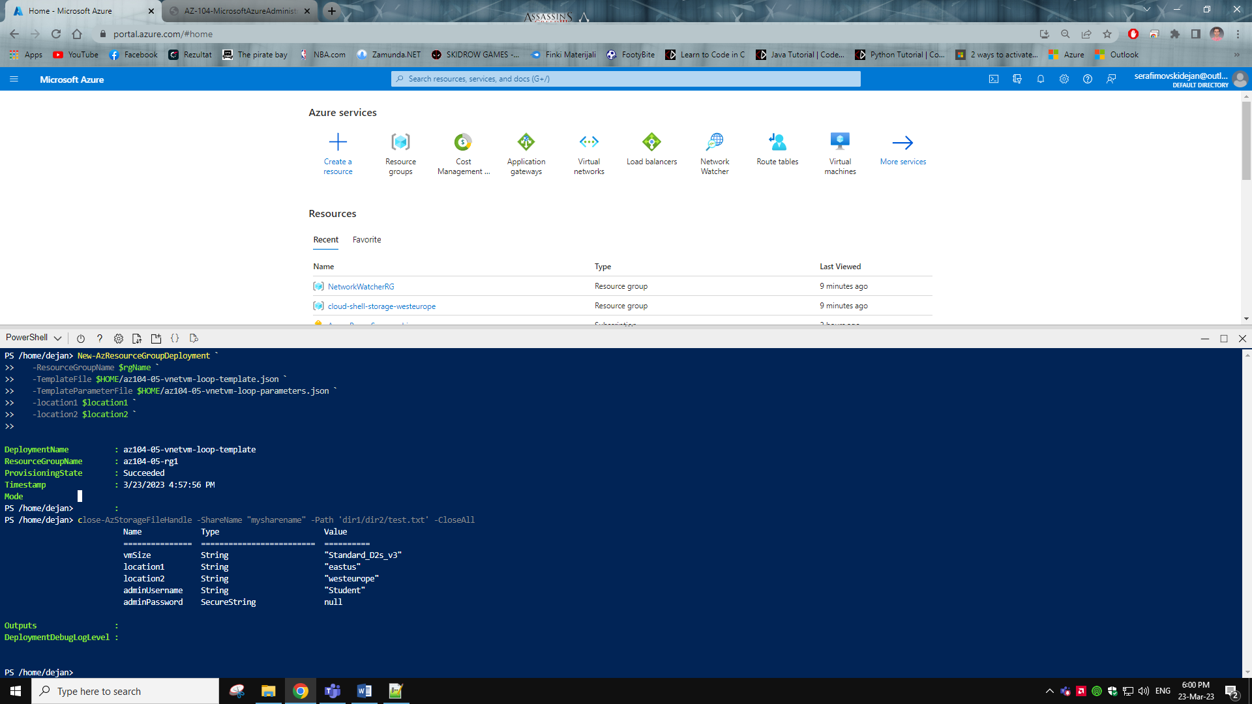

Task 2: Configuring network peering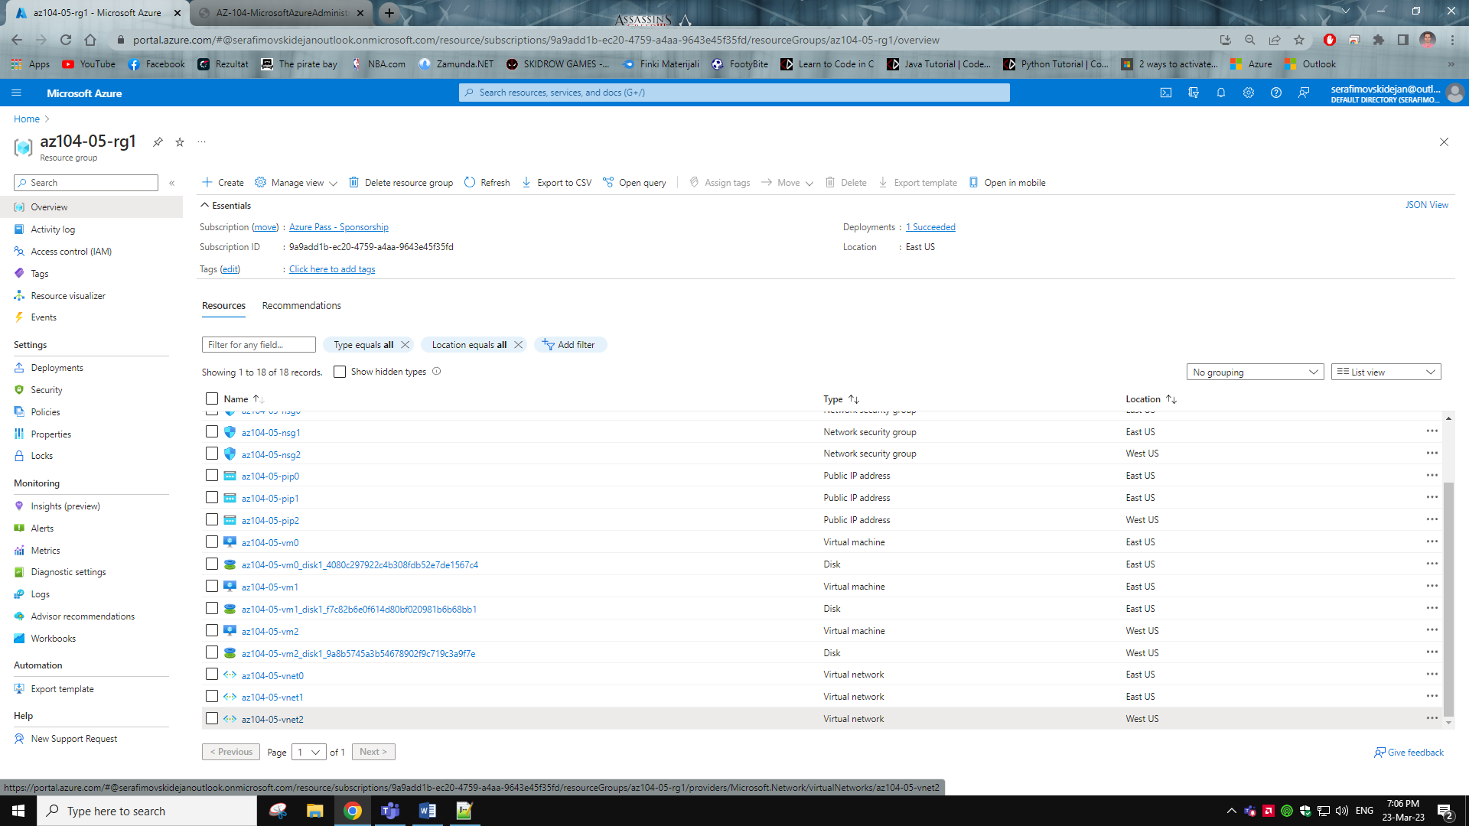

Task 3: Test VM connectivity

Testing connection from Vm0 to Vm1

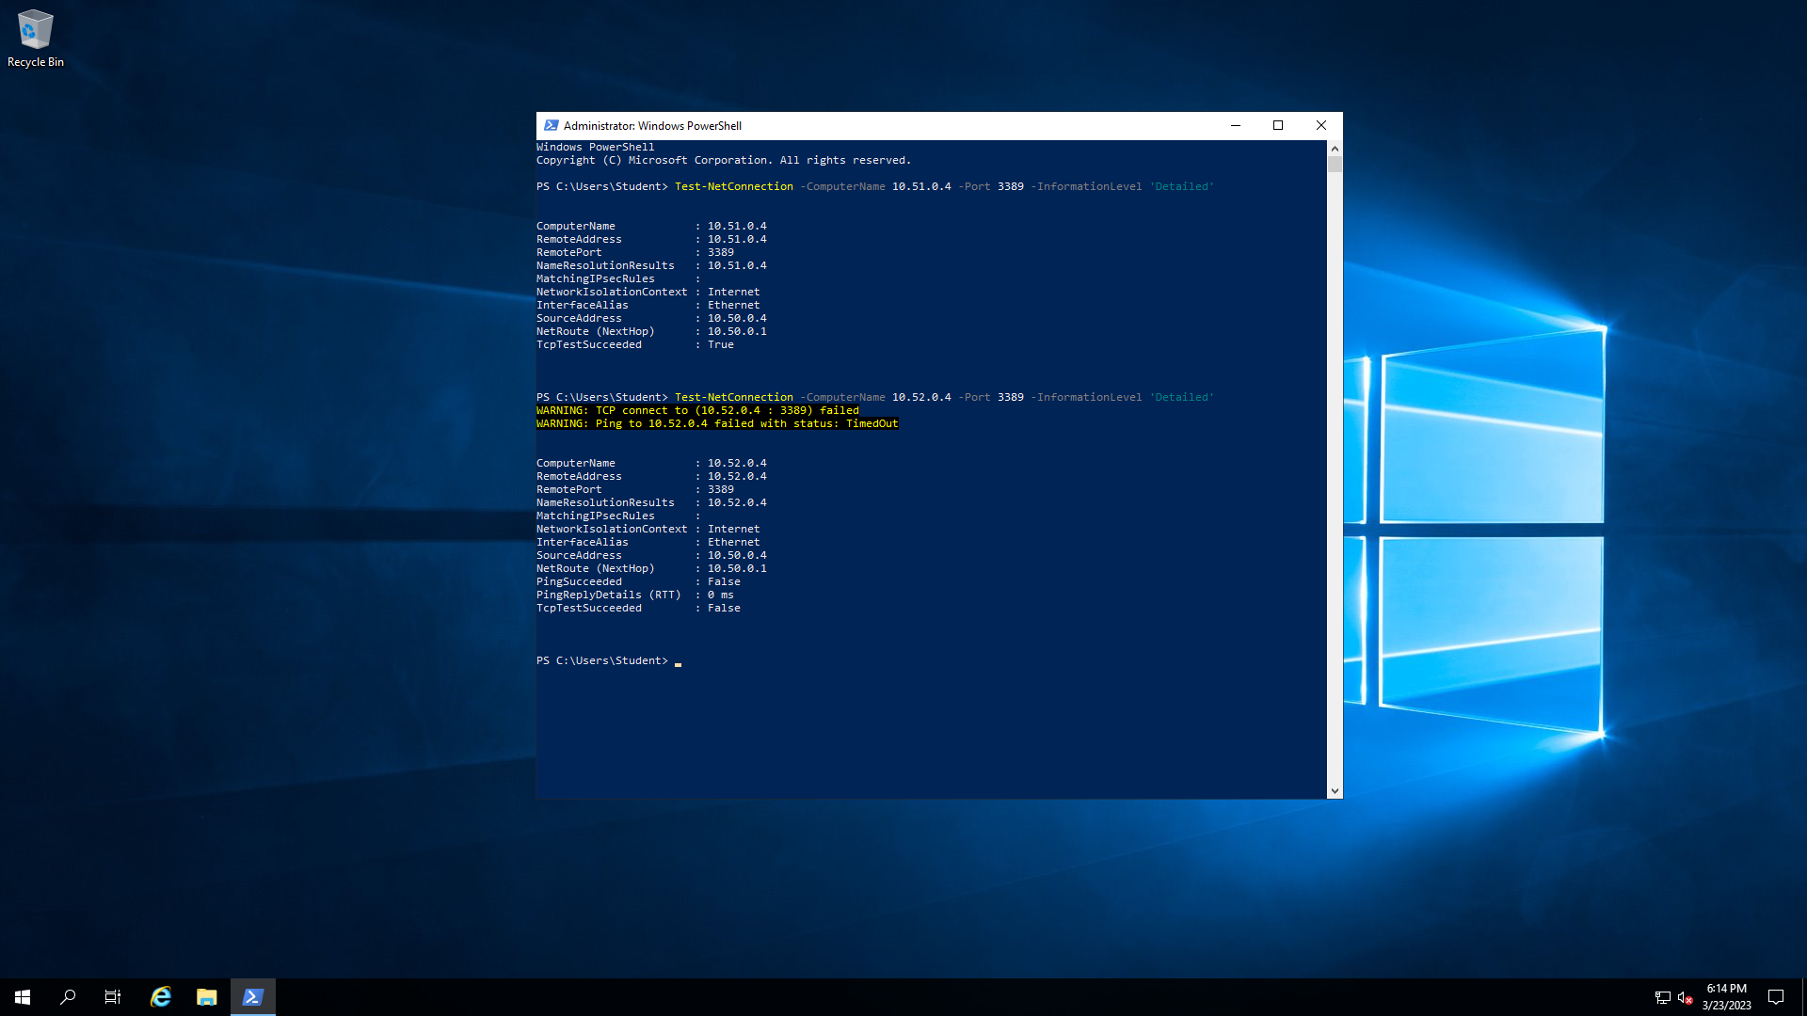

Testing connection from Vm1 to Vm2

